Teamgate (Trial)
Registration and Create App
Date: 26.09.2018.

1. Go to: https://teamgate.com/
and click the link "Start Free Trial".
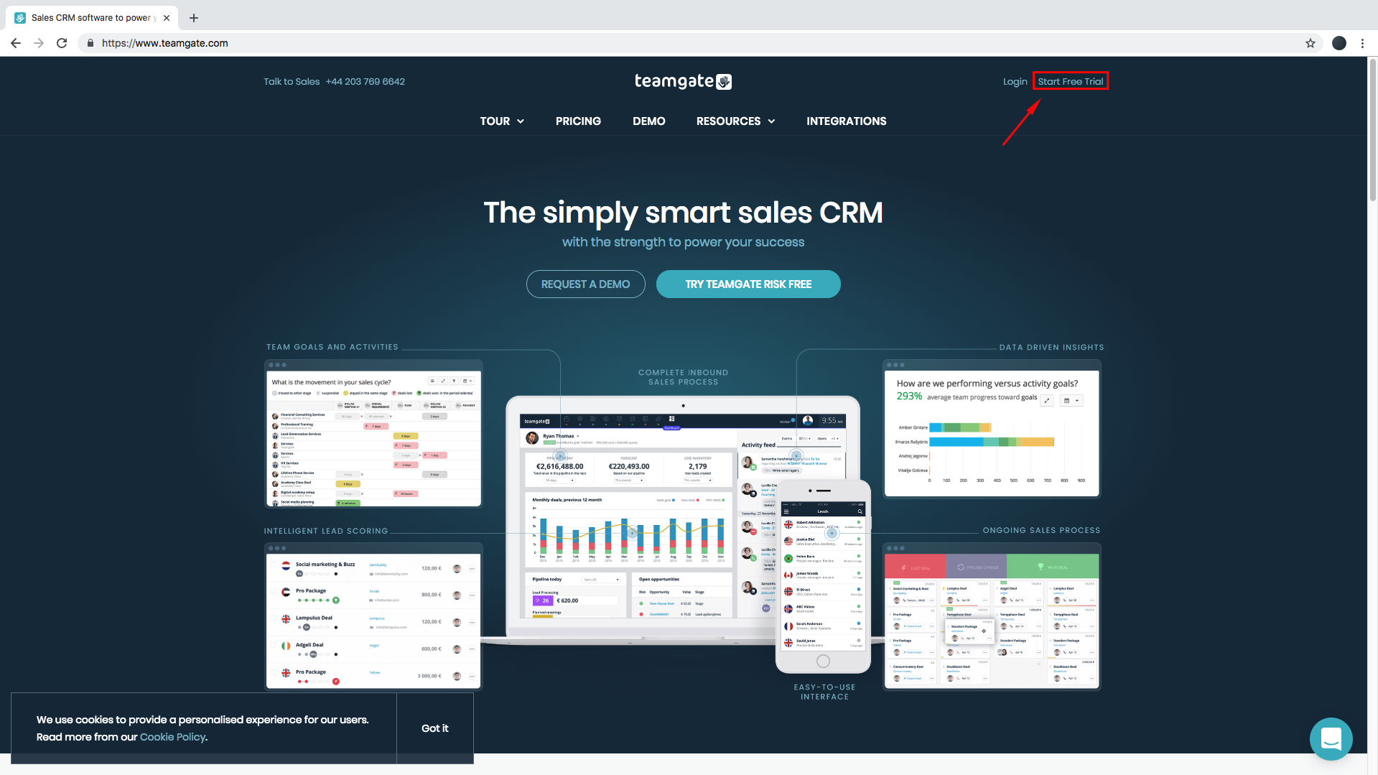
2. Fill all required fields and click on the button "Sign Up".
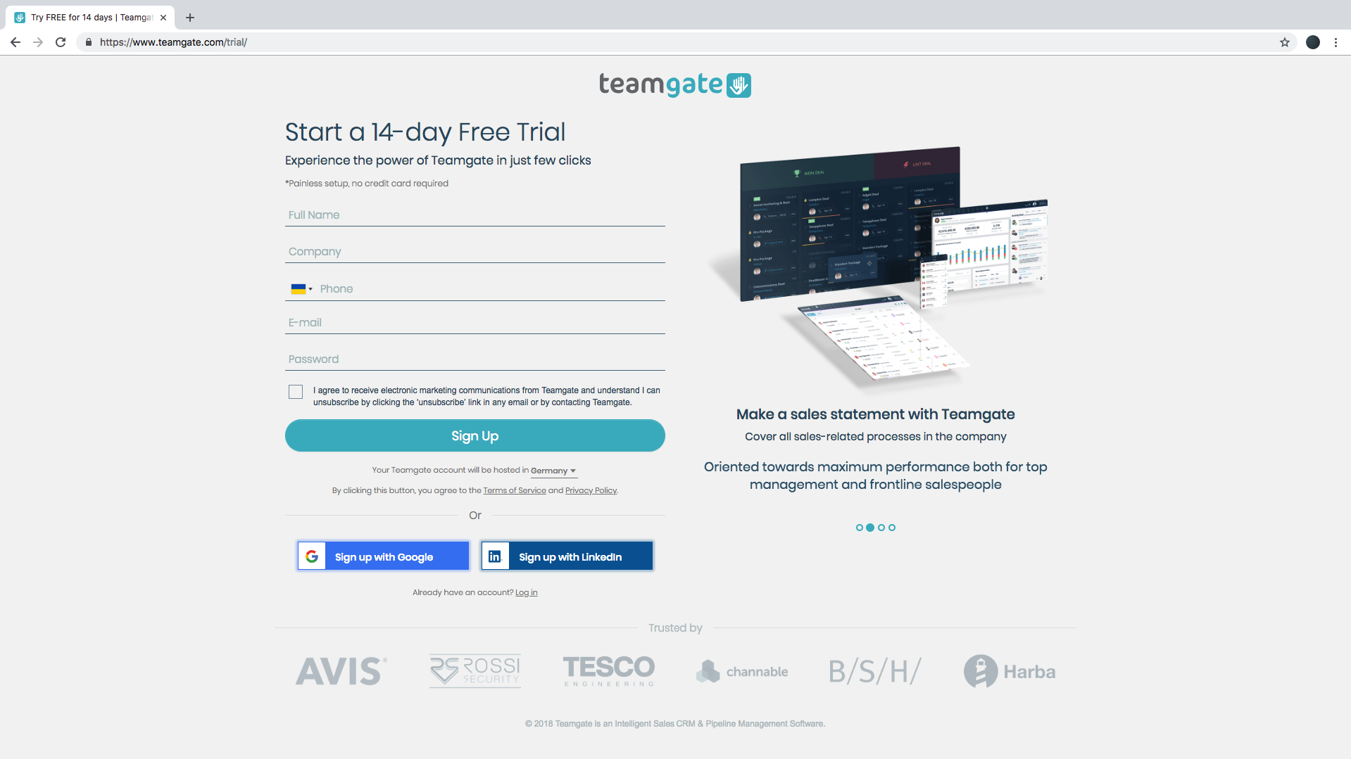

3. Wait while the account is setting up.
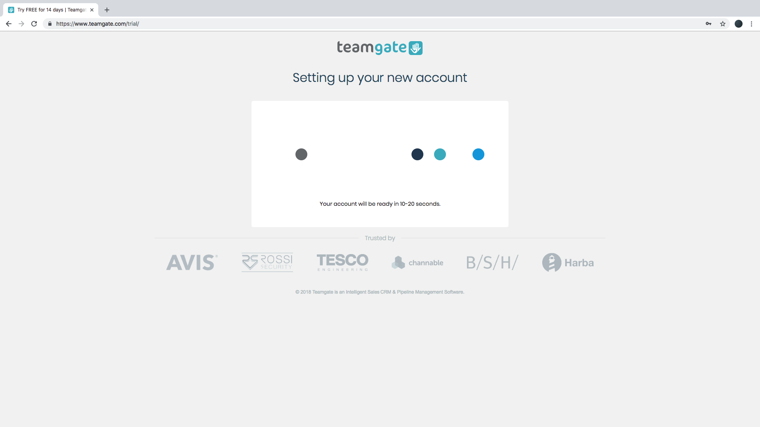
4. After setting up is done, you will be redirected to CRM account page.
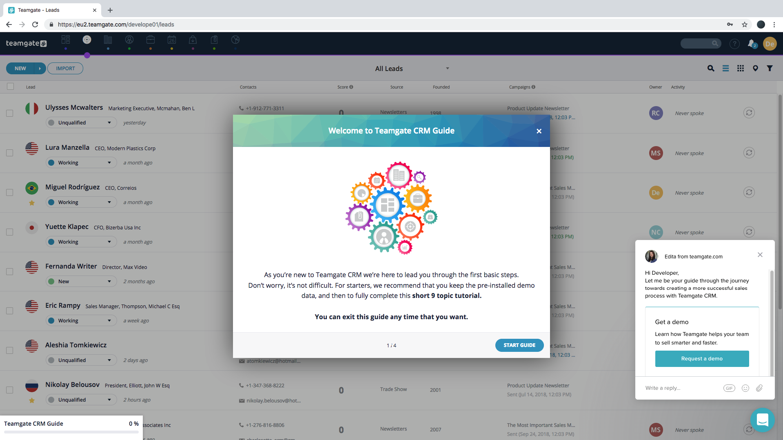

5. Go to profile menu.
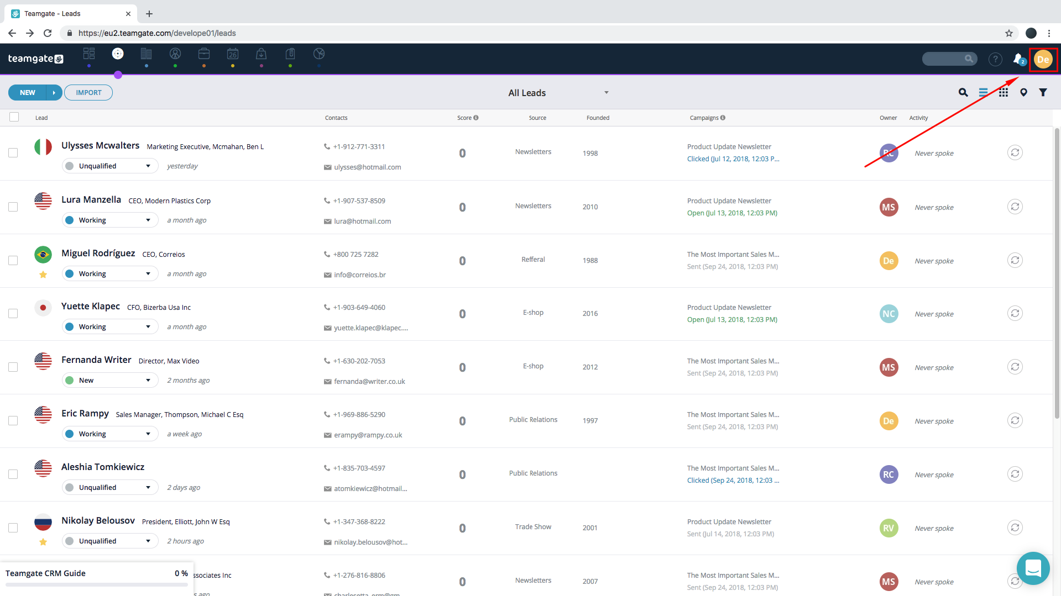
6. Select "Settings".
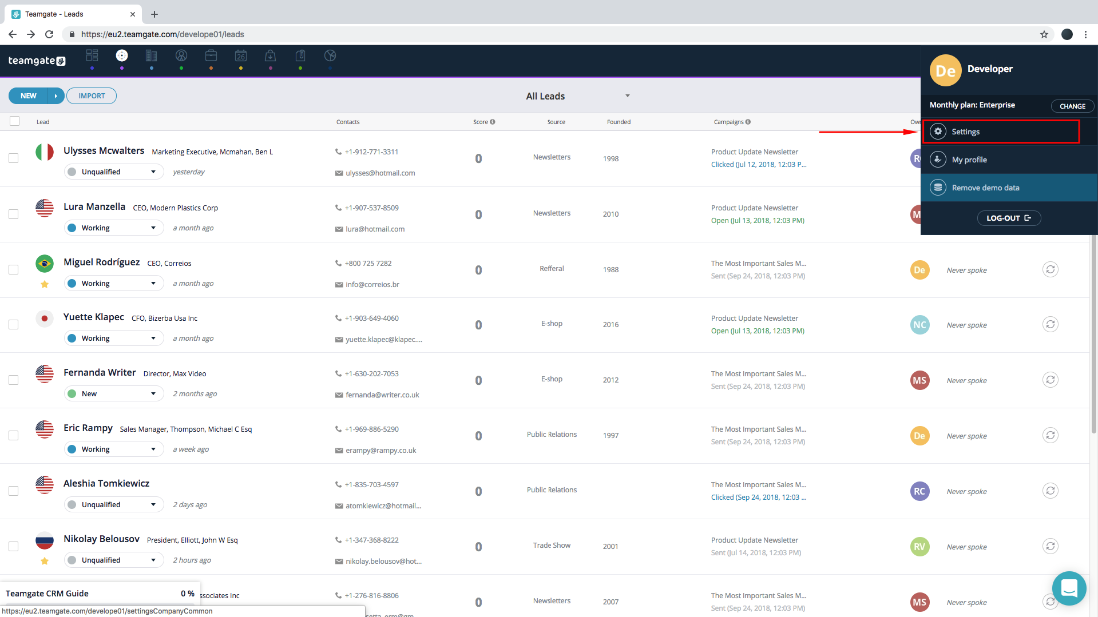

7. In the next page select "Additional features"
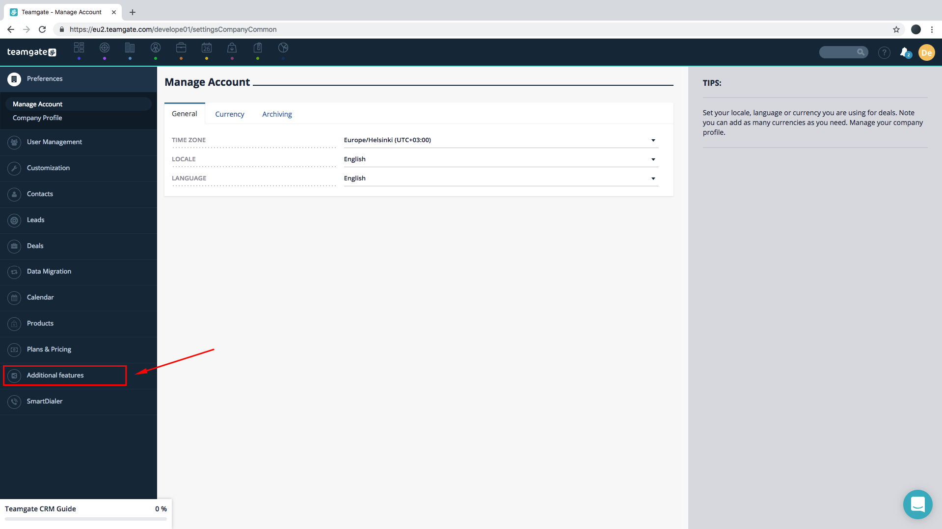
and then "External Apps".
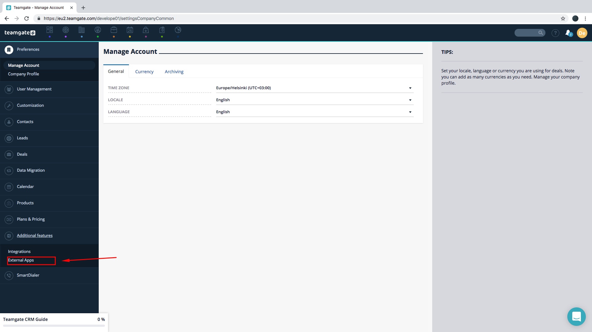

Then click on the link "New App Key Request".
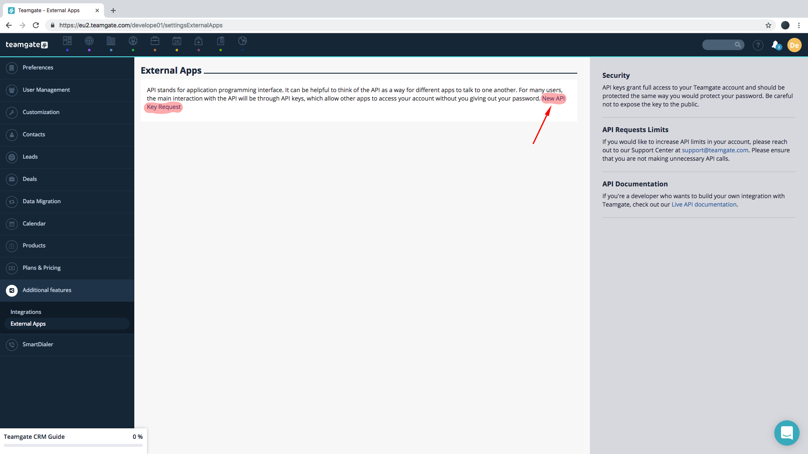
8. Set App name and click on button "CREATE".
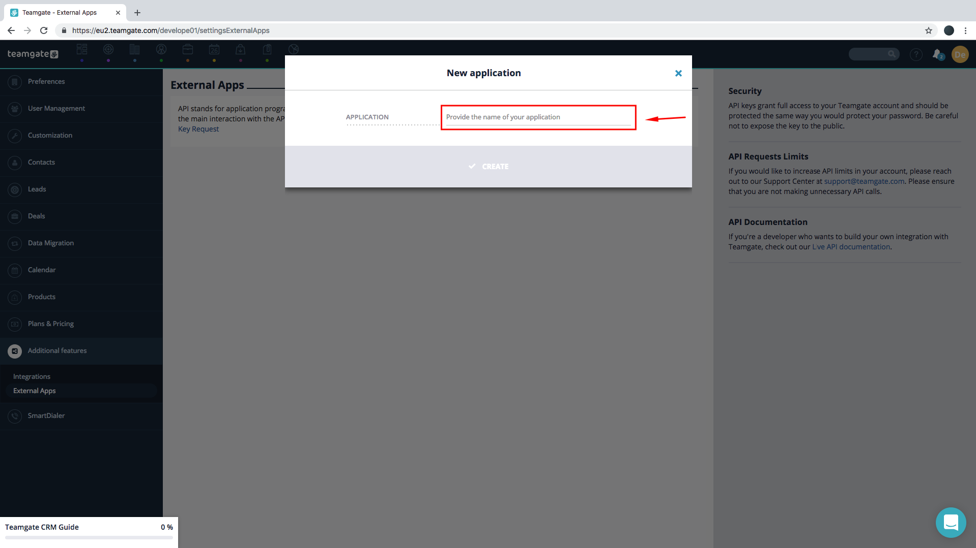

9. Select App.
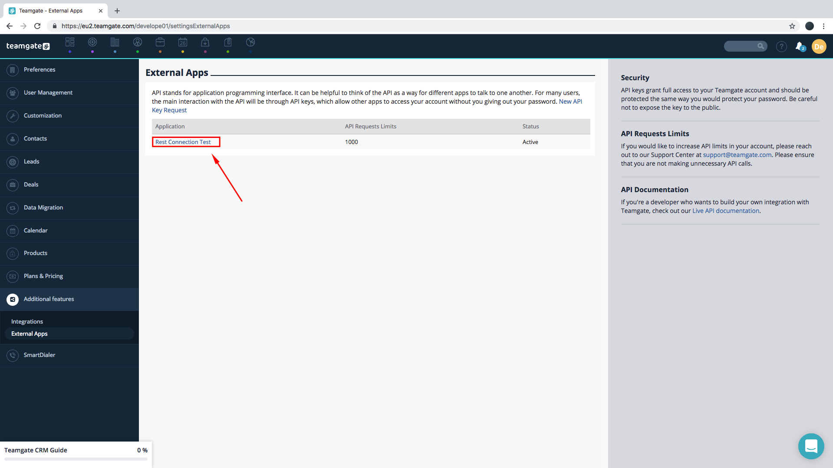
10. Copy your app_key to your App.
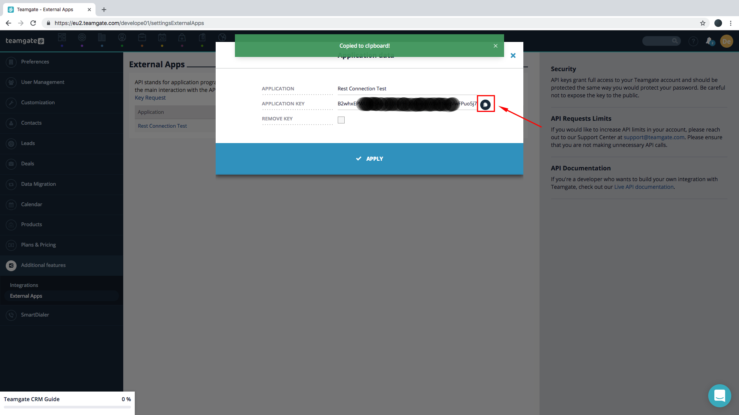

User's Auth Token.
For getting user’s auth token, your user must make a few steps:

1. In the profile menu select "My Profile".
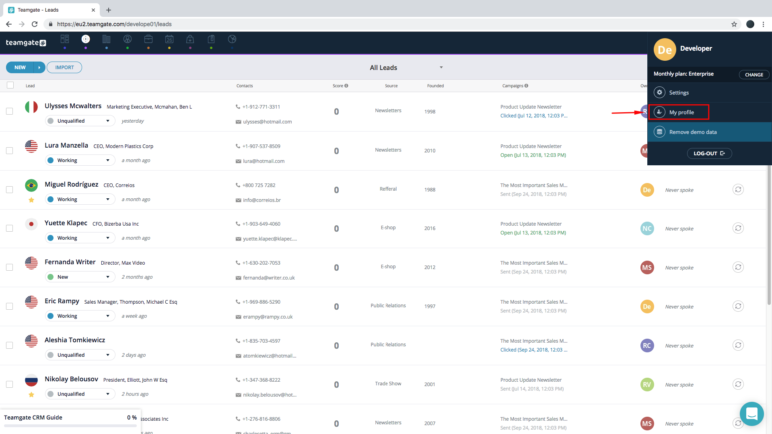
2. Select "Integrations" in the left menu.
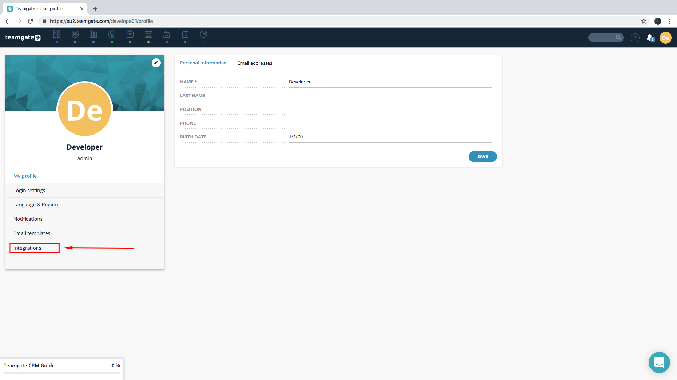

3. Click on the Tab menu "API Access".
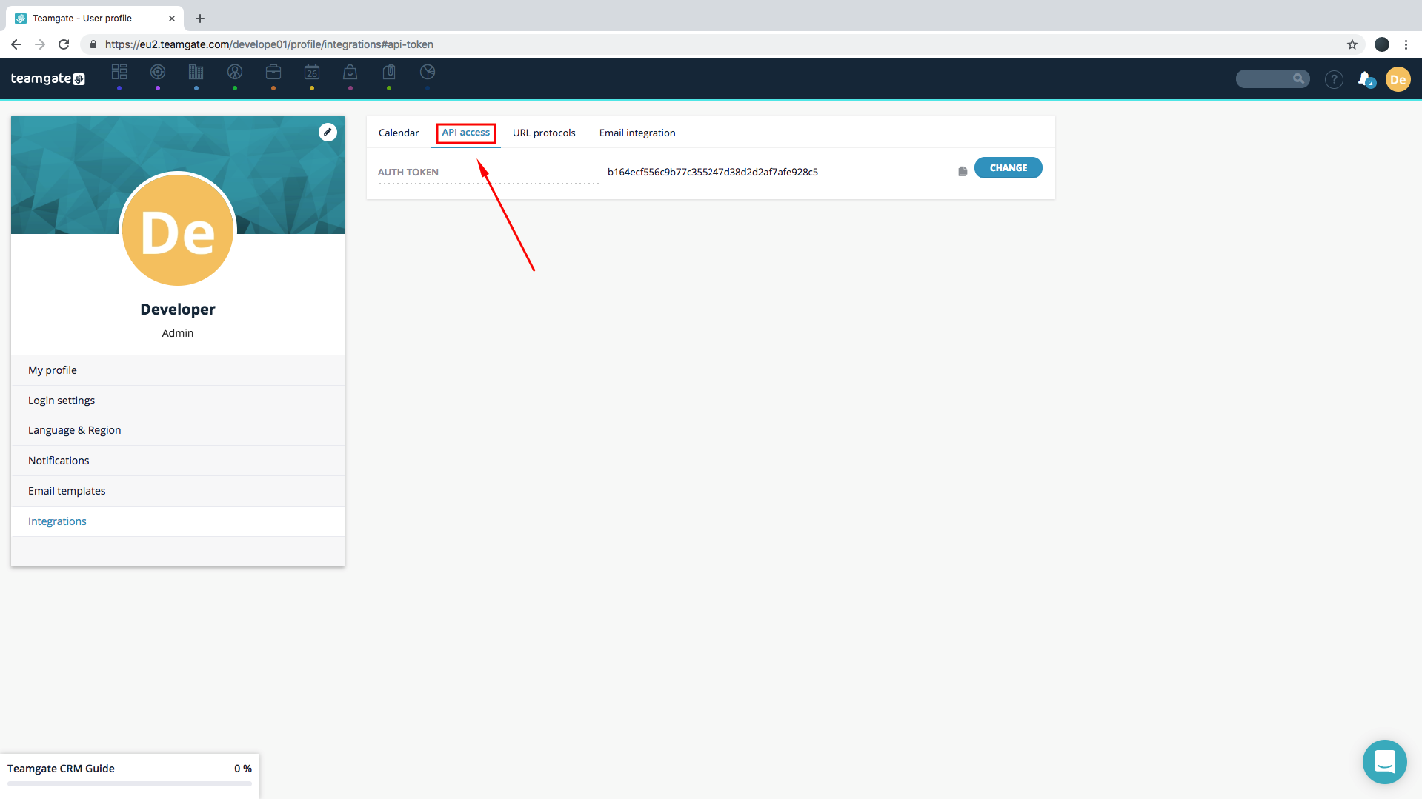
4. Copy the Auth Token.
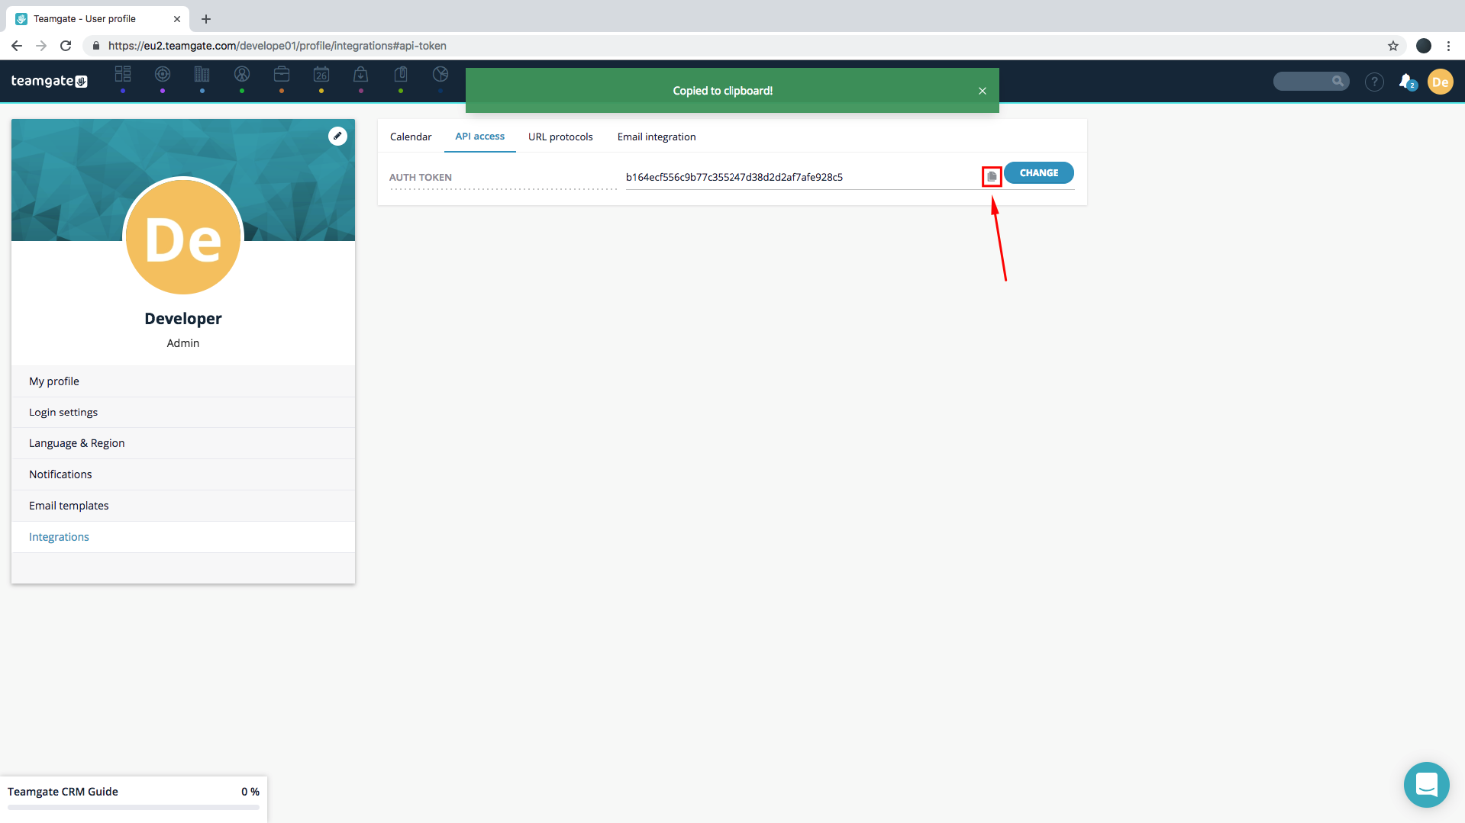

Good Luck.

